Template for Extended Abstracts for the 16th ****Asia-Pacific Conference on Giftedness (APCG 2020)****

First A. Author*1, Second B. Author2, and Third C. Author3

1 Korea Advanced Institute of Science and Technology (KAIST), Global Institute For Talented Education(GIFTED), Daejeon, Korea.

*2 Seoul National University, Dept. of Education, Seoul, Korea*

*3 Gyeongin National University of Education, Dept. of Computer Education, Anyang, Gyenggido, Korea*

*Corresponding author, e-mail: ..........................................

# ABSTRACT:

The executive committee has extended the pre-registration deadline until October 31st. The Conference Schedule will be uploaded on APCG2020 soon. These instructions have been prepared in the form that should be used as **Template of Extended Abstract.** **The paper to be presented at the conference will be included in the APCG2020: Book of Abstract. The publication will be in form of ABSTRACT (250 Words) or Extended Abstract (1,000 Words).** Abstract should be written with 11 font size, Times New Roman, single line spacing. The abstract should be concise and should contain no more than 250 words*.* Format using 2.54 cm (1") margins.

# Keywords:

Conference; conference paper; electronic files; information; paper template; submission.

The body text itself should be left and right justified. The extended abstract should contain the following sections**: Should include Introduction, Objectives, Methodology, Results, Discussion/Conclusion, and Recommendations with related references,** with each section headline written with Times New Roman font, 12 font size, bold, and all caps. These sections can be named differently and subsections can be included. The extended abstract can contain figures, tables and images. Pages should not be numbered.

Supporting figures, tables and images may be included. All the tables, images and figures should be centered. Figures and images should be numbered and figure captions should be placed under the figure or image. Please see Figure 1 for an example. The tables should also be numbered and the table caption should be placed at the top. Please see Table 1 for an example.

Table 1: Example Table

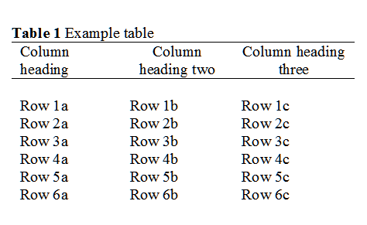



**Figure 1.** Example graph for the extended abstract.

# REFERENCES

References that have been presented inside (Auhtors, Year) in the full text should be prepared in the format of APA 6th